ASSIGNMENT 5.3
2303A51838 V.VIVEK BATCH 27
Ethical and Secure Use of AI-Generated Code

Task 1: Privacy and Data Security in AI-Generated Code
PROMPT: GENERATE AN LOGIN CODE IN PYTHON
CODE AND OUTPUT:
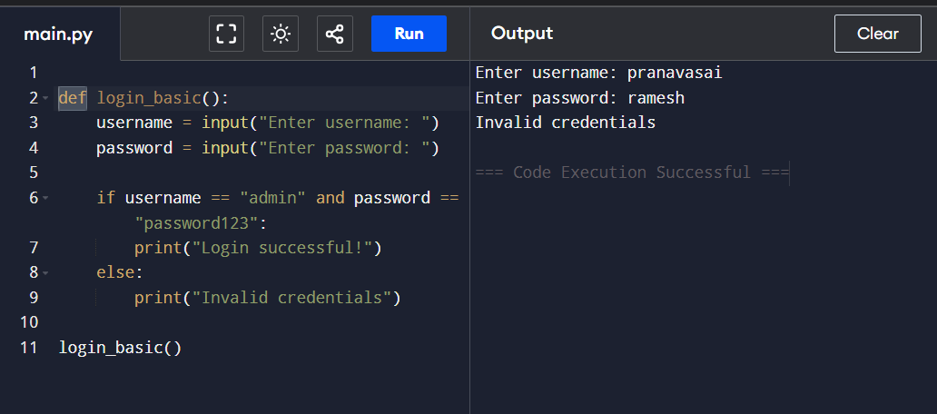
Security Issues Identified:
- Credentials are hardcoded
- Password is stored and compared in plain text
- No input validation or hashing
PROMPT: GENERATE A SECURE CODE
CODE AND OUTPUT: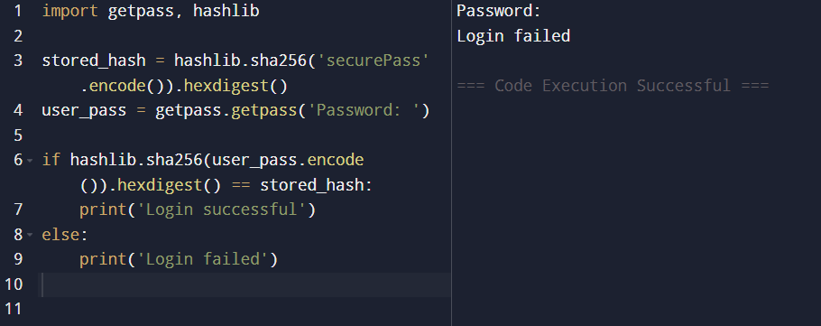

Improvements:
- Removed hardcoded credentials
- Used password hashing
- Used secure password input

Task 2: Bias Detection in AI-Generated Decision Systems
PROMPT:
Generate A Loan Approval Code (Biased Example):
CODE AND OUTPUT:
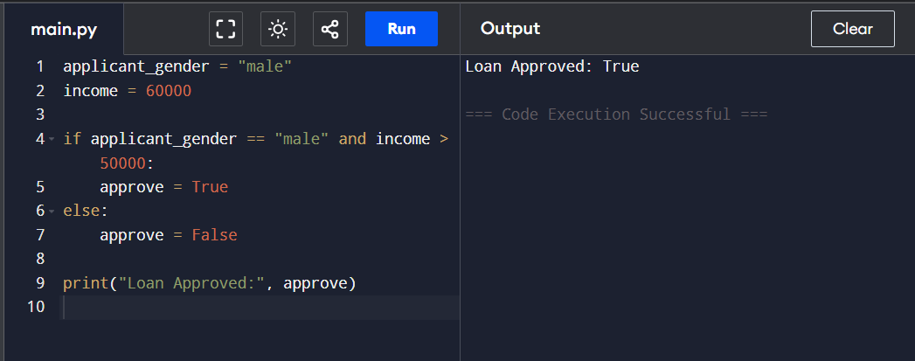
Bias Identified:
- Approval depends on gender
- Gender is irrelevant to loan eligibility
Fairness Discussion:
Such logic unfairly disadvantages applicants based on gender.
Mitigation Strategies:
- Remove gender from decision logic
- Use only financial criteria
- Regular bias audits

Task 3: Transparency and Explainability (Recursive Binary Search)
PROMPT: Generate a Recursive Binary Search Code:
Code and Output:

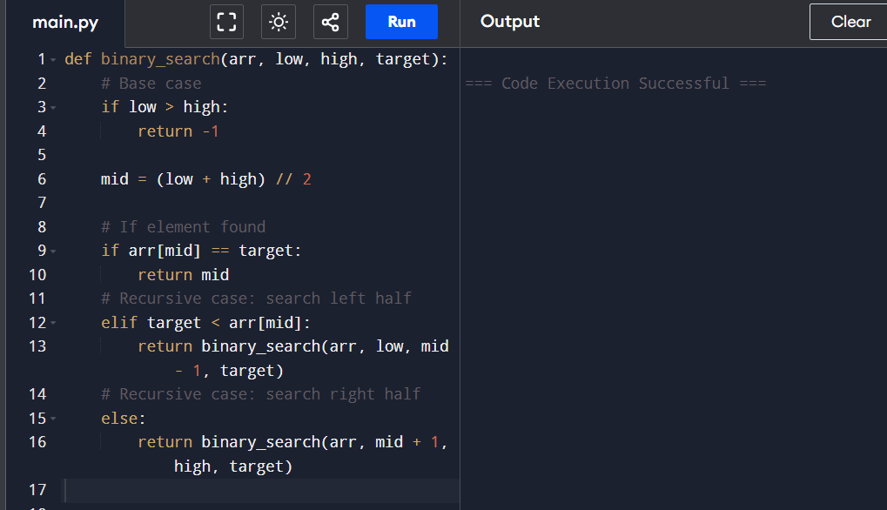

Explanation:
- Base case stops recursion when search range is invalid
- Recursive case reduces problem size each call
Code is beginner-friendly, well-commented, and logically clear.

Task 4: Ethical Evaluation of AI-Based Scoring Systems
PROMPT:Generatea Scoring Code:
CODE AND OUTPUT:
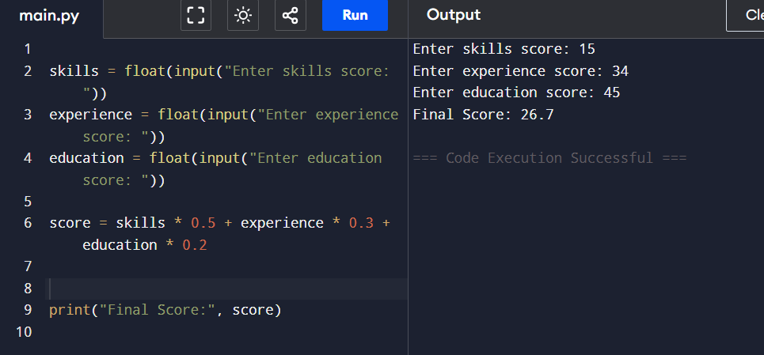

Bias Analysis:
- No gender or name used
- Logic is objective and skill-based
Ethical Evaluation:
Scoring is fair as it relies on job-relevant attributes.

Task 5: Inclusiveness and Ethical Variable Design
PROMPT: generate a code for bonus based on if gender is male
CODE:
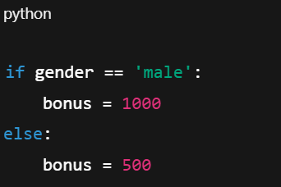
Issues:
- Gender-based assumptions
- Non-inclusive logic
Revised Inclusive Code:
PROMPT: GENERATE A CODE BASED ON PERFORMANCE
CODE AND OUPUT:
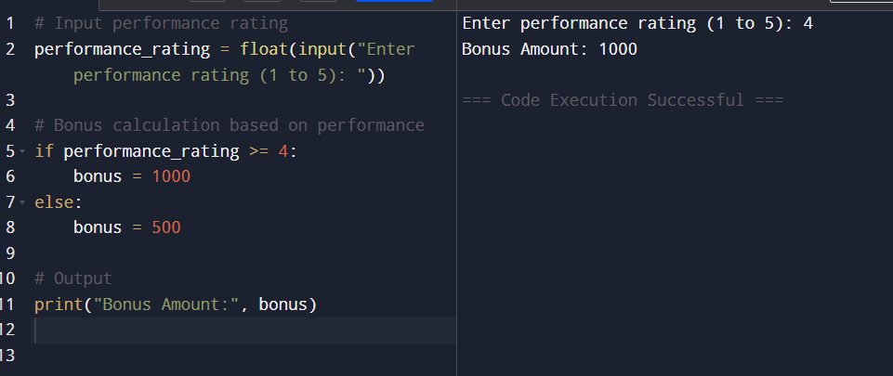
Improvements:
- Removed gender dependency
- Used performance-based logic

